Product Requirements Document (PRD) for Component 2
AgriOps AI: Component 2 (Farm Task & Worker Management) & Agent 2 (Crop Analysis Agent)
NOTE
Document Purpose: This Product Requirements Document (PRD) serves as the authoritative blueprint for the design, development, integration, and evaluation of Component 2 (Farm Task & Worker Management) and Agent 2 (Crop Analysis Agent) within the AgriOps AI platform. It aligns strictly with SE3090 academic evaluation standards, ensuring robust architectural design, human-in-the-loop safety gates, deterministic auditability, and seamless cross-platform execution.
System Overview & Scope Definition
1.1 Overarching Platform Context
AgriOps AI is an intelligent, agentic farm management ecosystem designed to streamline agricultural operations by uniting field workers and farm administrators under a shared digital infrastructure. The platform bridges physical field execution with centralized management and agentic intelligence through multi-tier architecture:
- Backend Infrastructure: C# ASP.NET version 10 Core Web API with a normalized PostgreSQL relational database.
- Field Worker Interface: Flutter mobile application for offline-capable field logging, task execution, camera evidence uploads, and AI recommendation delivery.
- Management Interface: React web dashboard for farm administration, task assignment, workload balancing, AI workflow monitoring, and human-in-the-loop approvals.
- Agentic AI Subsystem: A multi-agent framework comprising specialized domain agents:
  - Agent 1 (Farm Planning Agent): Master orchestrator for multi-step operational planning.
  - Agent 2 (Crop Analysis Agent): Multimodal visual and descriptive diagnostic support unit (Assigned Scope).
  - Agent 3 (Weather & Resource Planning Agent): Dynamic tool-use engine integrating live meteorological APIs.
  - Agent 4 (Validation & Safety Agent): Deterministic compliance and rule-validation filter.
.2 Assigned Component Scope
This document covers the end-to-end specification for the user's assigned scope:
- Component 2 — Farm Task & Worker Management: Manages human labor, task assignment, skill matching, scheduled maintenance/duties, and a multi-step evidence-verified task status lifecycle.
- Agent 2 — Crop Analysis Agent: Ingests field observation notes and mobile crop photographs to perform safe, non-pathological plant health risk assessments, feeding directly into the system's human-in-the-loop approval workflow.

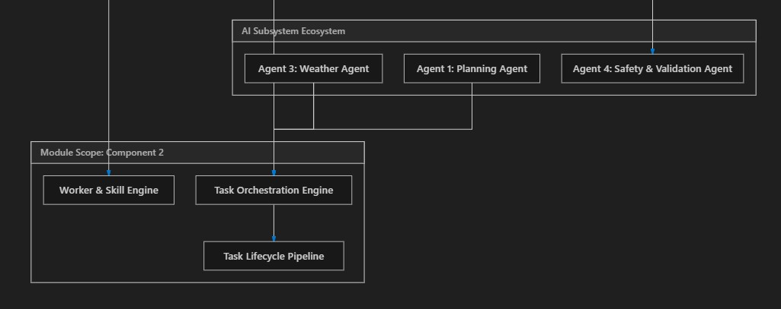
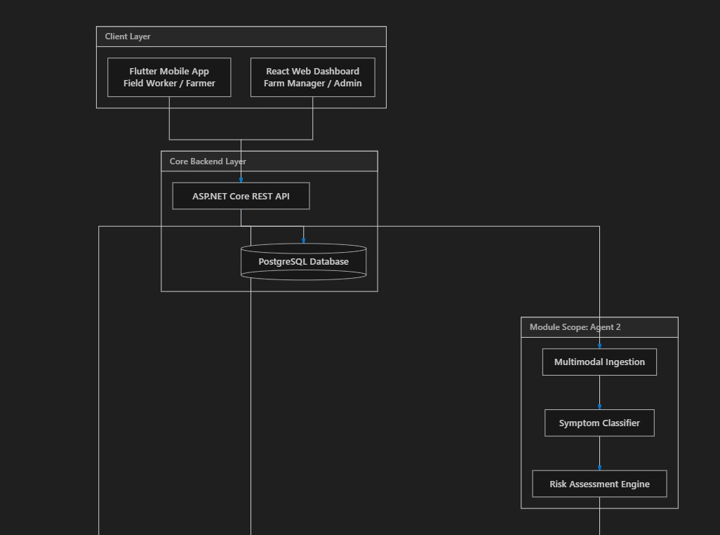

2. Persona & User Roles Matrix
Role | Primary Interface | Key Responsibilities & Capabilities within Component 2 & Agent 2
Farm Worker / Field Operator | Flutter Mobile | • Receives daily task notifications.  • Views assigned task lists with target fields and instructions.  • Updates task statuses (Pending $→$ In Progress $→$ Pending Verification).  • Captures and uploads photo evidence and field notes via mobile camera.  • Triggers crop health analysis by uploading symptom photos and notes.
Farm Manager | React Web Dashboard | • Creates and schedules operational farm tasks.  • Assigns workers based on skill certifications and current workload.  • Reviews uploaded worker evidence (photos/notes).  • Verifies and completes tasks.  • Reviews AI Crop Analysis findings and approves suggested field interventions.
Agronomist / Admin | React Web Dashboard | • Configures crop types, growth stage benchmarks, and stress indicators.  • Audits historical AI decision trails and worker execution logs.  • Overrides or refines AI crop health assessments.

3. Detailed Requirements: Component 2 (Farm Task & Worker Management)
3.1 Business Objectives & Core Features
Component 2 handles day-to-day operational execution. It ensures that farming plans created by managers or recommended by AI agents are assigned to qualified personnel, tracked through a strict 7-step lifecycle, and verified with photographic evidence before final completion.
Key features include:
- Operational Task Orchestration: Support for diverse task types (Watering, Fertilization, Weeding, Pest Inspection, Crop Monitoring, Harvesting, Equipment Maintenance).
- Skill-Based Workload Balancing: Task assignment matching worker skills/certifications (e.g., machinery handling, chemical safety) while monitoring worker allocation to prevent burnout.
- Strict Status Lifecycle Workflow: A controlled state machine replacing simple CRUD updates with multi-actor validation.
- Task Scheduling Engine: Support for recurring schedules (daily, weekly, bi-weekly) with automatic task instance generation.
- Inventory & Crop Linking: Direct relationships anchoring tasks to Field and CropSeason (Component 1) and triggering material consumption in Inventory (Component 3).

Activity Diagram
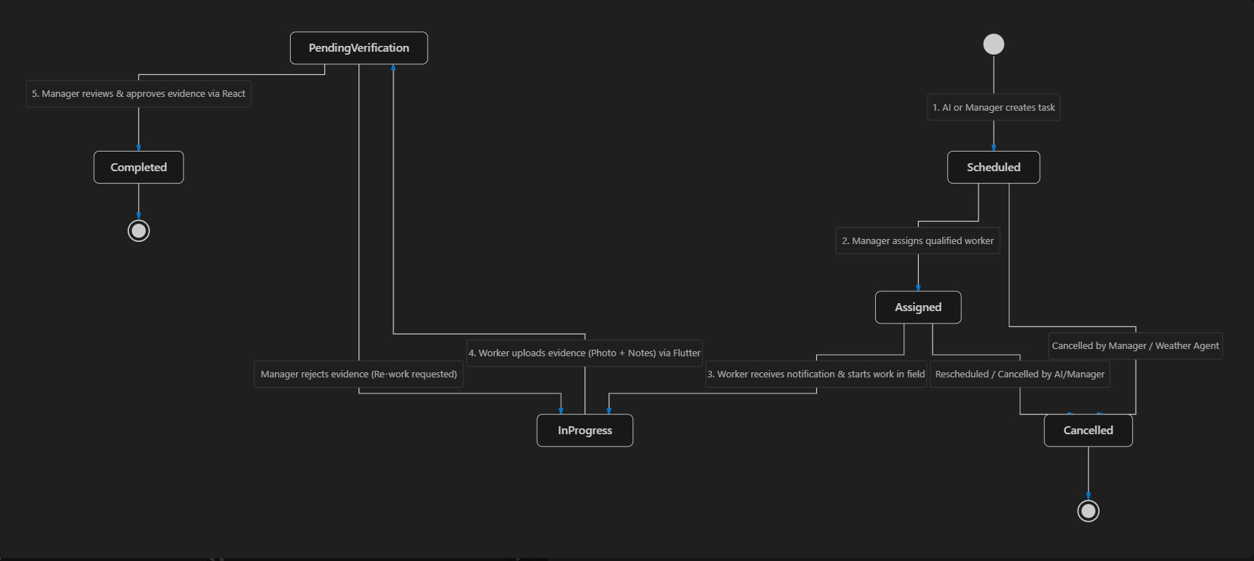

Step-by-Step Operational Sequence:
- Creation: Task created manually by Farm Manager on React or automatically generated by Agent 1 (Planning Agent). Initial Status: Scheduled / Pending.
- Assignment: System verifies WorkerSkill matches TaskType. Worker assigned. Status: Assigned.
- Notification & Initiation: Push/pull payload delivered to Flutter mobile app. Worker taps "Start Task". Status: In Progress.
- Physical Execution: Worker performs field activity (e.g., applying fertilizer to Field A).
- Evidence Upload: Worker snaps field photo, adds remarks, and submits via Flutter. Status shifts to Pending Verification.
- Manager Verification: Farm Manager receives notification on React Web, inspects the evidence photo and notes. Manager clicks Approve.
- Completion & Downstream Triggers: Status changes to Completed. Triggers automatic inventory deduction in Component 3 (if applicable) and writes audit log to TaskHistory.

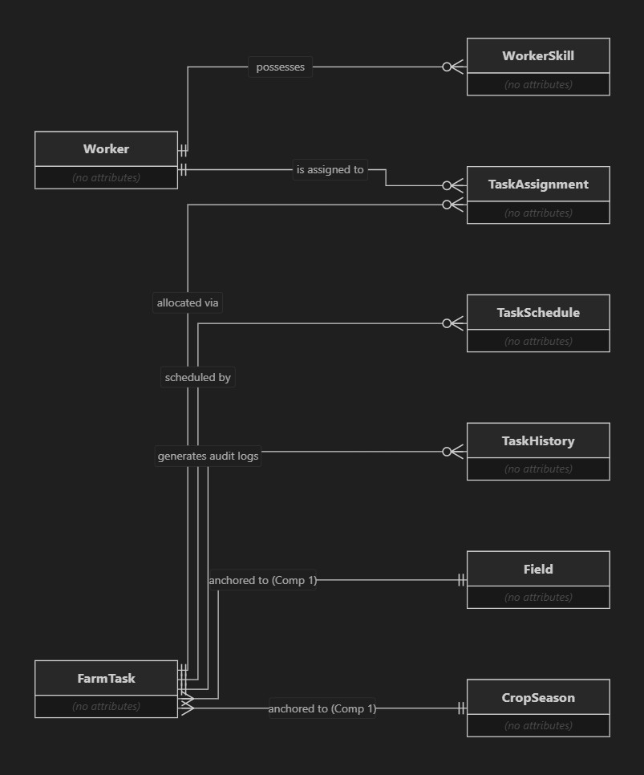
DB Schema

API Specifications (ASP.NET Core REST API)
Endpoints Summary:
- POST /api/v1/tasks - Create a new farm task.
- GET /api/v1/tasks - Filtered search for tasks (by status, priority, worker, field, date range).
- GET /api/v1/tasks/{id} - Fetch detailed task view including history and assignments.
- POST /api/v1/tasks/{id}/assign - Assign a worker to a task (verifies worker skill compatibility).
- PATCH /api/v1/tasks/{id}/status - Worker updates status (In Progress).
- POST /api/v1/tasks/{id}/submit-evidence - Upload photo evidence & notes (shifts status to Pending Verification).
- POST /api/v1/tasks/{id}/verify - Manager approves/rejects evidence (shifts status to Completed or returns to In Progress).
- GET /api/v1/workers/{id}/workload - Check worker active task load and assigned skills.

4. Detailed Requirements: Agent 2 (Crop Analysis Agent)
Mission, Role & Defense/Safety Philosophy
Agent 2 (Crop Analysis Agent) serves as the specialized visual and descriptive diagnostic support unit within the AgriOps AI multi-agent subsystem.
IMPORTANT
Safety and Defense Architecture (Viva Defense Requirement):
Agent 2 does NOT attempt to provide definitive medical or pathological diagnoses (e.g., claiming 100% certainty of Cladosporium fulvum fungal infection). Providing unvalidated disease diagnoses without lab assays is dangerous in real farming and vulnerable during academic viva evaluation.
Instead, Agent 2 is explicitly engineered as an AI-Assisted Crop Health Assessment Unit. It identifies stress indicators (e.g., chlorosis, leaf wilting, necrosis, nitrogen deficiency patterns, environmental heat stress) and formulates structured recommendations for field verification. All findings are passed to Agent 4 (Validation & Safety Agent) and queued for human agronomist/manager approval.
Example Parameters
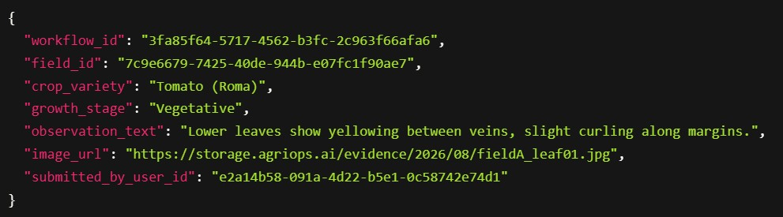

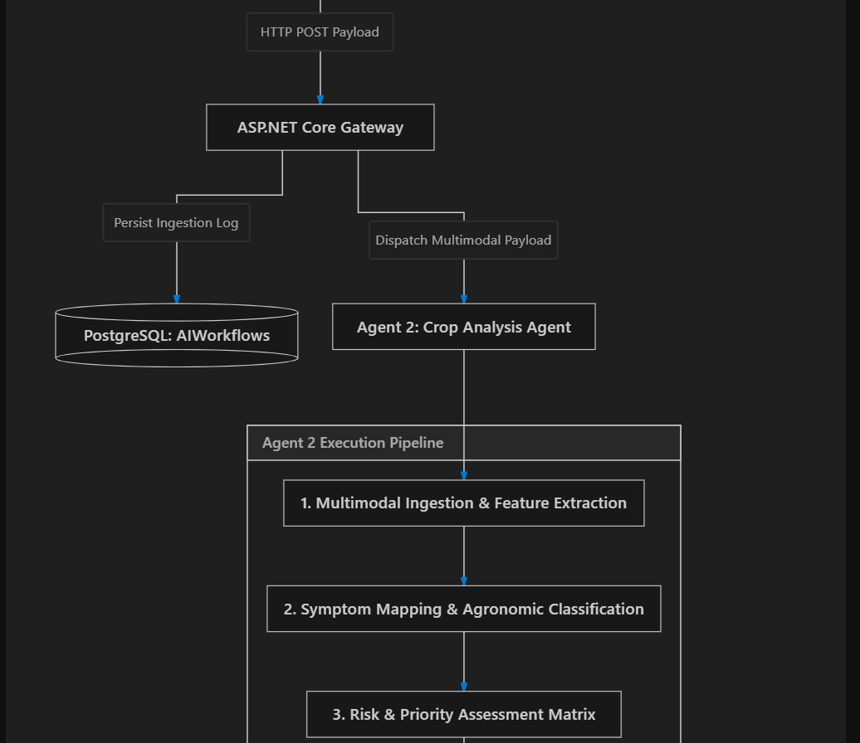
Execution of Crop Analysis Agent

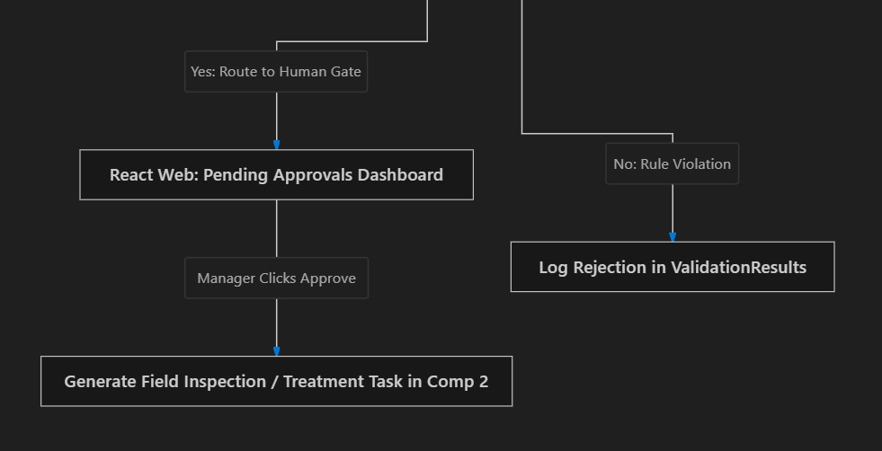
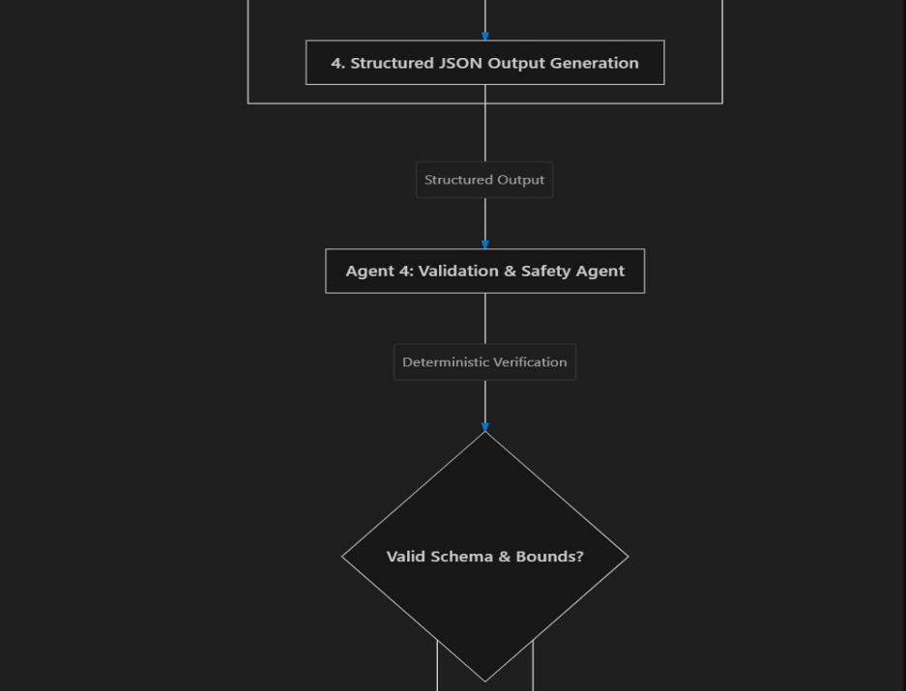

Execution Stages:
- Multimodal Ingestion: Ingests image stream and text description securely via ASP.NET Core backend.
- Symptom Mapping & Classification: Cross-references visual indicators (e.g., chlorosis, tip burn) and worker text notes against agronomic knowledge bases associated with the crop's current growth stage (Vegetative).
- Risk & Priority Categorization: Computes risk score based on affected area, crop vulnerability, and growth stage impact. Formulates potential stress factors, recommended actions, and urgency rating.
- Handoff to Agent 4 & React Approval Gate: Packages structured JSON output and hands off to Agent 4 for rule checking before displaying on the React Manager Dashboard.
AI Observability & State Persistence
To satisfy SE3090 requirements for auditability and observability, every step of Agent 2's execution is written to PostgreSQL audit tables:
- AIWorkflows: Logs the overarching workflow request (WorkflowType = 'CropAnalysis').
- AgentExecutions: Records Agent 2 start time, execution duration (ms), input payload, and output JSON.
- ToolCall: Logs any secondary queries (e.g., retrieving Component 1 soil records or growth stage parameters).
- ValidationResult: Stores validation pass/fail status emitted by Agent 4.
- Approvals: Tracks human review decisions (Approved / Rejected / Revised) made by the Farm Manager.
How do Component 2 and Agent 2 integrates with other components ?
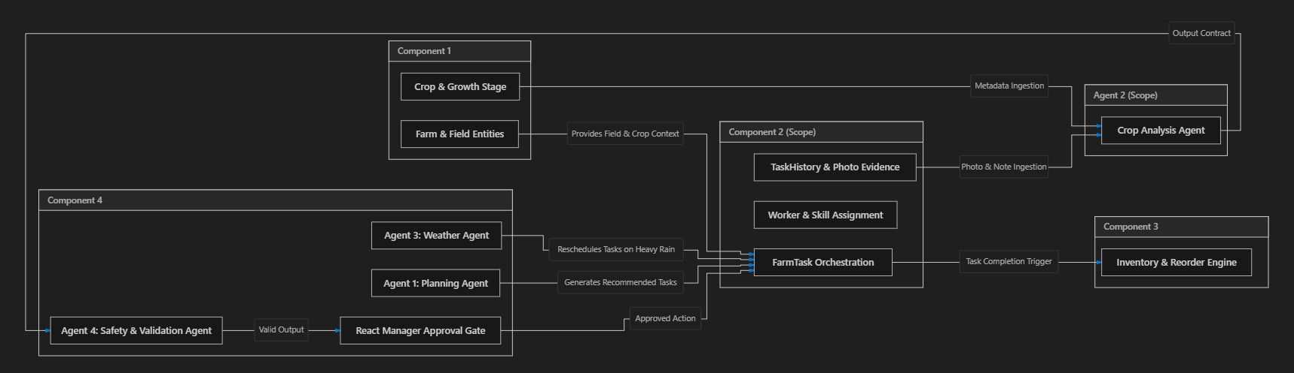

Direct Integration Hooks:
- Component 1 (Farm & Crop Management) $→$ Component 2 & Agent 2:
  - Every FarmTask must link to a valid FieldId and CropSeasonId.
  - Agent 2 ingests CropName, Variety, and GrowthStage from Component 1 to contextualize visual symptom analysis.
- Component 2 $→$ Component 3 (Inventory & Resources):
  - When a worker completes a Fertilization or PestInspection task in Component 2, task completion triggers an inventory consumption transaction in Component 3 (e.g., deducting 15 kg of Fertilizer A).
- Agent 2 $→$ Agent 4 $→$ Component 4 (Approvals):
  - Agent 2 outputs structured recommendations to Agent 4. Upon passing validation checks, the recommendation is created as an Approval record displayed on the React Web Dashboard.
- Agent 1 & Agent 3 $→$ Component 2:
  - Agent 1 (Planning Agent) schedules operational tasks into Component 2.
  - Agent 3 (Weather Agent) monitors third-party forecasts and updates task schedules in Component 2 (e.g., changing status from Scheduled to Cancelled/Rescheduled if heavy rain is detected).
Farm Manager Oriented Sequence Diagram
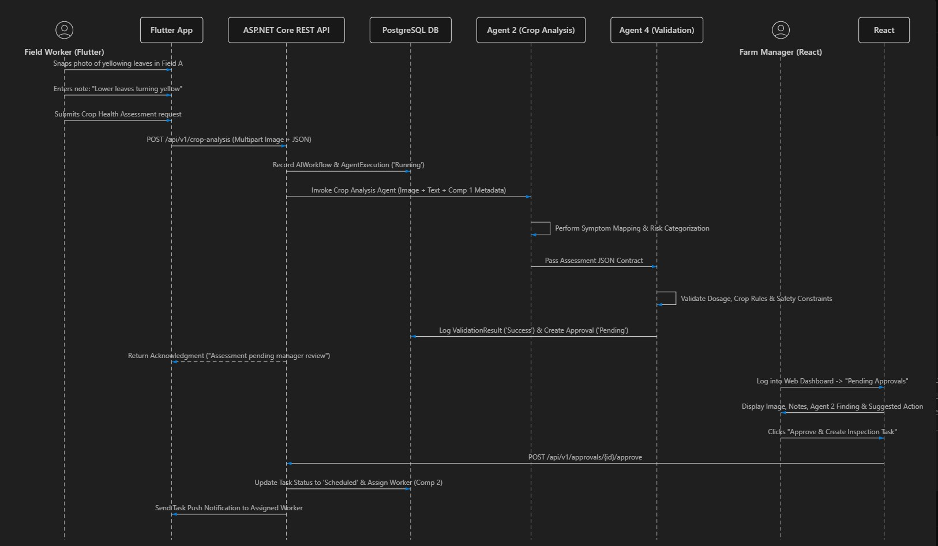

User Interface & User Experience Requirements
Flutter Mobile Application (Field Worker)
- Today's Tasks Screen:
  - Clean list of assigned tasks categorized by urgency (High, Medium, Low).
  - Task card displays target field name, crop type, scheduled time, and action button ("Start Task").
- Task Execution & Evidence Upload Screen:
  - Camera integration allowing direct photo capture or gallery selection.
  - Multiline text area for operational notes/remarks.
  - One-tap submission button moving status to Pending Verification.
- Crop Diagnostics Screen:
  - Camera launcher for photographing crop health issues.
  - Growth stage selector pre-populated from Component 1.
  - Real-time status tracker showing AI evaluation progress and manager feedback.
React Web Dashboard (Farm Manager / Agronomist)
- Task Orchestration & Scheduling Dashboard:
  - Drag-and-drop task assignment board (Kanban view: Pending, In Progress, Pending Verification, Completed).
  - Worker workload heat-map highlighting worker utilization rates.
- Evidence Verification Portal:
  - Split-screen inspection view: Left side displays worker evidence photo and notes; Right side displays task details and Verify/Approve vs Request Re-work buttons.
- AI Recommendations & Crop Analysis Inbox:
  - Centralized view of all Agent 2 crop health assessments.
  - Visual display of uploaded symptom photos alongside AI identified stress indicators and confidence levels.
  - One-click action to convert AI recommendations into active Component 2 tasks.
Non-Functional Requirements & Evaluation Checklist
Performance & Scalability
- API Latency: Task state transitions and CRUD operations must respond in $<200\text{ ms}$.
- Multimodal AI Latency: Agent 2 processing (image ingestion + multimodal assessment) must complete within $<4.5\text{ seconds}$.
- Database Efficiency: Foreign key indexes on FieldId, CropSeasonId, WorkerId, and TaskId to ensure fast search/filter queries across large datasets.
Security & Data Integrity
- Role-Based Access Control (RBAC):
  - Workers can only update tasks assigned to them and submit field evidence.
  - Managers and Admins have exclusive permission to create tasks, assign workers, verify evidence, and approve AI recommendations.
- Backend Service Isolation: API keys for external services and AI models are stored securely in backend configuration (appsettings.json / environment variables) and never exposed to Flutter or React clients.
Deterministic Auditability & Observability
- All task state changes logged to TaskHistory with PreviousStatus, NewStatus, ChangedByUserId, timestamp, and evidence URLs.
- Complete AI tracing stored in AIWorkflows, AgentExecutions, and ValidationResults.

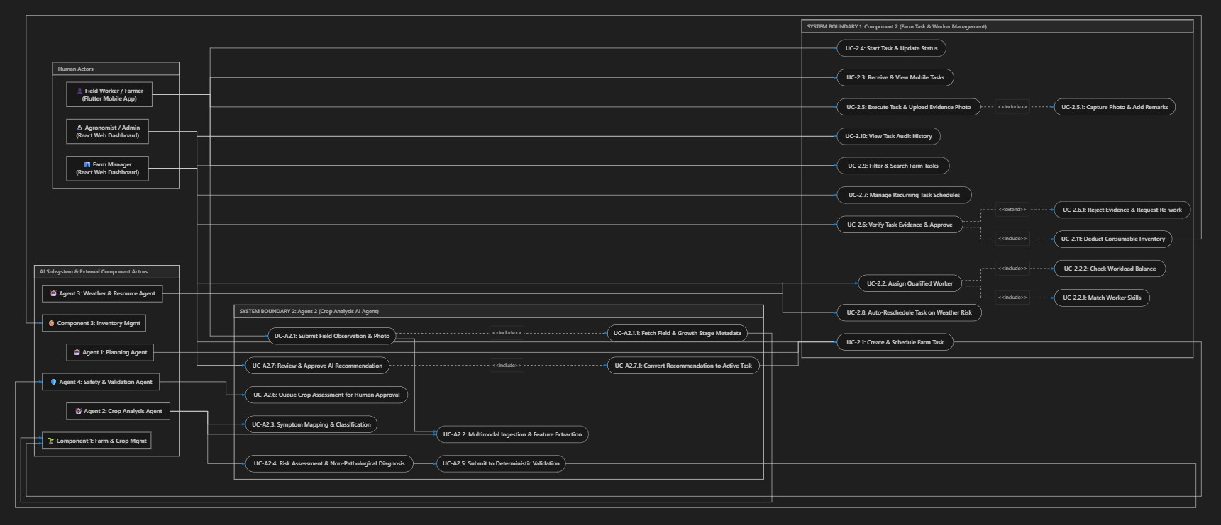
Use Case Diagram

Component 2: Key Use Case Specifications
Use Case UC-2.2: Assign Qualified Worker to Task
- Primary Actor: Farm Manager
- Secondary System: Component 2 Backend
- Preconditions: A FarmTask exists in Pending / Scheduled state.
- Triggers: Farm Manager selects a task and clicks "Assign Worker" on the React Dashboard.
- Includes: UC-2.2.1 (Match Worker Skills), UC-2.2.2 (Check Workload Balance).
- Main Success Scenario:
  - Farm Manager opens the task assignment modal on React.
  - System queries active Workers filtered by required WorkerSkills (e.g., ChemicalHandling for Fertilization).
  - System calculates active task load for candidate workers to prevent overburdening.
  - Manager selects qualified worker (e.g., John Doe) and submits.
  - System records TaskAssignment, updates FarmTask.Status to Assigned, and emits push notification to Flutter app.
- Alternate Flow (Skill Mismatch):
  - If the manager selects a worker lacking required certification, the system flags a warning modal requiring explicit manager override or blocking assignment.
Use Case UC-2.5 & UC-2.6: Task Execution, Evidence Upload & Verification
- Primary Actors: Field Worker (Flutter), Farm Manager (React)
- Secondary System: Component 3 (Inventory)
- Includes / Extends:
  - UC-2.5 includes UC-2.5.1 (Capture Photo & Add Remarks).
  - UC-2.6 extends UC-2.6.1 (Reject Evidence & Request Re-work).
  - UC-2.6 includes UC-2.11 (Deduct Consumable Inventory).
- Main Success Scenario:
- Worker arrives at target field (e.g., Field A) and taps "Start Task" on Flutter (Status: In Progress).
- Worker performs physical task (e.g., applies 15 kg of Fertilizer A).
- Worker uses mobile camera to capture photo of applied field, enters remarks ("Fertilizer applied evenly"), and taps "Submit Evidence".
- Status changes to Pending Verification.
- Farm Manager receives notification on React, views uploaded evidence photo and worker notes.
- Manager clicks Approve.
- Status changes to Completed. System logs entry in TaskHistory and automatically triggers inventory deduction in Component 3.
- Alternate Flow (Evidence Rejected):If photo is blurry or work is incomplete, Manager clicks Reject / Request Re-work with feedback notes. Task reverts to In Progress and notifies worker.
Agent 2: Key Use Case Specifications
Use Case UC-A2.1 to UC-A2.6: Multimodal Crop Health Analysis & Validation
- Primary Actors: Field Worker (Flutter), Agent 2 (Crop Analysis), Agent 4 (Validation), Farm Manager (React)
- Preconditions: Field worker is physically near a field with observed crop anomalies.
- Main Success Scenario:
  - Worker opens Flutter "Crop Diagnostics" screen, selects target field (Field A - Tomato), snaps photo of yellowing leaves, types description ("Leaves turning yellow with dark spots"), and submits.
  - Backend fetches CropVariety (Roma Tomato) and GrowthStage (Vegetative) from Component 1 (UC-A2.1.1).
  - Agent 2 ingests multimodal payload, extracts visual features (chlorosis patterns), and maps symptoms against tomato agronomic rules.
  - Agent 2 computes risk assessment: Potential Issue: Magnesium / Nitrogen Nutrient Deficiency (Medium Risk). Recommended Action: Perform field inspection & apply foliar spray.
  - Agent 2 formats structured JSON output and sends to Agent 4 (Validation Agent).
  - Agent 4 runs rule-based checks (verifying recommended chemical compatibility and field dosage safety bounds).
  - Upon successful validation, Agent 4 writes an Approval record (Status: Pending) and displays item on React Dashboard under Pending Approvals.
Use Case UC-A2.7: Review & Approve AI Recommendation
- Primary Actor: Farm Manager / Agronomist (React Web)
- Includes: UC-A2.7.1 (Convert Recommendation to Active Task).
- Main Success Scenario:
  - Farm Manager opens Pending Approvals tab on React Web.
  - Dashboard displays uploaded leaf photo, worker notes, Agent 2 analysis findings, confidence rating, and recommended action.
  - Manager reviews and clicks Approve & Create Task.
  - System executes UC-A2.7.1, which automatically generates a new FarmTask in Component 2 (TaskType: PestInspection / Fertilization, Target: Field A).

Include & Extend Relationship Summary Table
Source Use Case | Relationship | Target Use Case | Business Logic Rationale
UC-2.2: Assign Worker | <<include>> | UC-2.2.1: Match Skills | Worker skill certification must always be verified before assignment.
UC-2.2: Assign Worker | <<include>> | UC-2.2.2: Check Workload | Active workload balance must be computed to prevent scheduling conflicts.
UC-2.5: Execute Task | <<include>> | UC-2.5.1: Capture Photo | Proof of physical work requires camera evidence upload via Flutter.
UC-2.6: Verify Evidence | <<extend>> | UC-2.6.1: Reject Evidence | Triggered conditionally if uploaded photo evidence fails manager inspection.
UC-2.6: Verify Evidence | <<include>> | UC-2.11: Deduct Inventory | Approved task execution automatically triggers material decrements in Comp 3.
UC-A2.1: Submit Observation | <<include>> | UC-A2.1.1: Fetch Comp 1 Metadata | Image analysis requires crop variety and growth stage context from Comp 1.
UC-A2.7: Review AI Proposal | <<include>> | UC-A2.7.1: Convert to Task | Approving an AI recommendation automatically spawns an actionable task in Comp 2.

